Studio Lab: Fourier Analysis of Waveforms
In this studio lab you will capture and analyze the acoustic waveforms made by a number of different sound sources. You will learn how use the LabPro/LoggerPro computer interface and software and develop skills using Fourier analysis techniques.
Getting Used to the Interface
You will need to attach the microphone and USB cable to the LabPro interface. The USB cable connects the interface to the computer which then uses LoggerPro to communicate with the interface and capture your data. We will spend the first 15 minutes learning how to do this. |  | 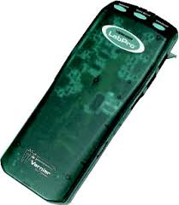
One of the most important parts of the program is the Experiment tab on the menu bar. Open this and select the Data Collection option. This allows you to adjust the sampling rate and duration of time over which to sample. In general you should sample at a rate 2 times higher than the maximum frequency you wish to measure. Since you could be interested in high harmonics (several thousand Hz) you will probably start around 10 000 samples per second for your data rate.  (Total duration will be typically less than 1 second)  Also – have a tuning fork at hand to help confirm that data collection is working properly. |  | 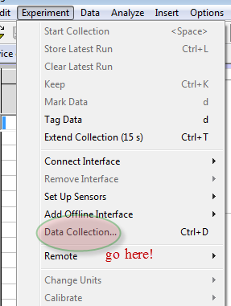
Collecting Waveforms
You should collect a minimum of 4 sets of waveforms and their corresponding FFT (Fast Fourier Transform Graphs). You sets should include:
- A wind instrument
- A stringed instrument
- Human Voice (try different sung vowels)
- Test tube!
(but please feel free to explore more sounds!)
For each sound source please complete the following similar to the sample template:
Sound Source:
My voice singing “ah” – note the Pavarotti-like perfection!

Wave Form  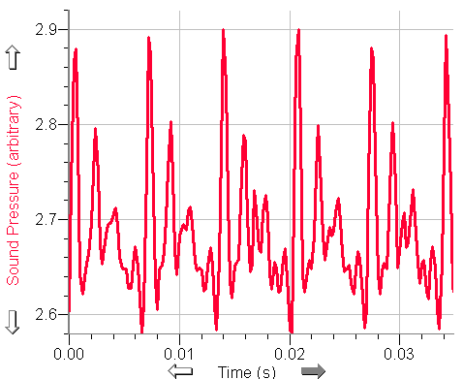 | Fast Fourier Transform  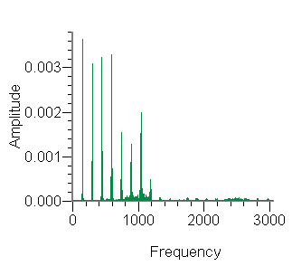
Frequency Range: 0 – 3000 Hz
Sampling rate: 10kHz

Identification of Harmonics/Overtones :
There are 8 easily identified harmonics starting at 148.3 Hz D3 (I’m 17 cents sharp)

What was the Fundamental Frequency/Note produced?

F1 = 148.3
F2 = 295.4 (2F1)
Etc
Comments:

This looks like a series of all harmonics. How would a trained voice – singing “musically” differ from this?

How to Collect the Waveforms
When you are ready to capture a waveform, press the “Collect” button on the top menu bar. It should be green when it is ready to collect data

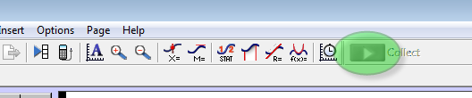
The waveform will appear on the screen.
Next – click the Insert button and then Additional Graphs / FFT Graph to display the frequency spectrum for the waveform that you just captured.

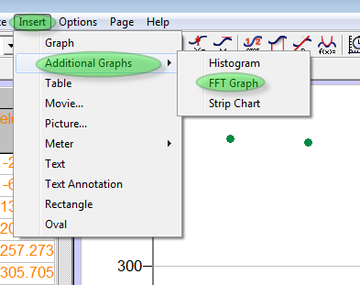

This is very easy and you should collect lots of waveforms to help you understand how a complex sound can be composed of many interacting (simpler) tones. We will explore this more in future classes.
You may either sketch the waveforms/FFT graphs or cut and paste them into a word document. These are for your notes but I will want to see what you have done so be prepared to share them with me!
(Hint: you can use the Snipping Tool in Windows7 to capture images and cut&paste them into documents)

Sound Source:

Wave Form | Fast Fourier Transform
Frequency Range:
Sampling rate:

Identification of Harmonics/Overtones :

What was the Fundamental Frequency/Note produced?

Comments:

